Octal (Base 8)
# Source: AI Source: Provided by: [Data Path: Persons Table -> ID Column: 1, Name_En Column: Motasem Essam] -> From: [ChatGPT] on [7/16/2026]
The Octal Numeral System is a positional numeral system with a base (radix) of 8. It uses eight digits, from 0 to 7, to represent numbers. Each digit's value depends on its position, with each position representing a power of 8.
Historically, octal was widely used in early computers because one octal digit corresponds exactly to three binary digits (bits). Although hexadecimal is more common today, octal is still used in some areas of computing, particularly in UNIX/Linux file permissions and certain embedded systems.

Definition
# Source: AI Source: Provided by: [Data Path: Persons Table -> ID Column: 1, Name_En Column: Motasem Essam] -> From: [ChatGPT] on [7/16/2026]
The Octal Numeral System is a positional numeral system in which every digit represents a power of 8.
It is denoted as Base 8.
An octal numeral consists only of the digits
$$\boxed{0, 1, 2, 3, 4, 5, 6, 7}$$

Base (Radix)
# Source: AI Source: Provided by: [Data Path: Persons Table -> ID Column: 1, Name_En Column: Motasem Essam] -> From: [ChatGPT] on [7/16/2026]
The base of the octal system is
$$\boxed{8}$$
This means:
- Eight unique digits are used.
- Each position represents a power of 8.

Digits
# Source: AI Source: Provided by: [Data Path: Persons Table -> ID Column: 1, Name_En Column: Motasem Essam] -> From: [ChatGPT] on [7/16/2026]
The octal system uses the digits
$$\boxed{0, 1, 2, 3, 4, 5, 6, 7}$$
Digits 8 and 9 are not valid in octal numbers.

Place Values
# Source: AI Source: Provided by: [Data Path: Persons Table -> ID Column: 1, Name_En Column: Motasem Essam] -> From: [ChatGPT] on [7/16/2026]
From right to left, the place values are
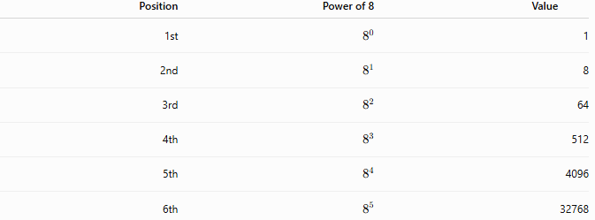
Position | Power of 8 | Value
1st | $$8^{0}$$ | 1
2nd | $$8^{1}$$ | 8
3rd | $$8^{2}$$ | 64
4th | $$8^{3}$$ | 512
5th | $$8^{4}$$ | 4096
6th | $$8^{5}$$ | 32768

General Representation
# Source: AI Source: Provided by: [Data Path: Persons Table -> ID Column: 1, Name_En Column: Motasem Essam] -> From: [ChatGPT] on [7/16/2026]
An octal numeral
$${\left(d_{n}d_{n-1}⋯d_{1}d_{0}\right)}_{8}$$
has the value
$$\boxed{\sum_{k=0}^{n}{d_{k}}8^{k}}$$
where each digit satisfies
$$0≤d_{k}<8.$$

Examples
# Source: AI Source: Provided by: [Data Path: Persons Table -> ID Column: 1, Name_En Column: Motasem Essam] -> From: [ChatGPT] on [7/16/2026]
Example 1
Octal number
$${527}_{8}$$
Expanded form
$$5×8^{2}+2×8^{1}+7×8^{0} \\ =5×64+2×8+7 \\ =320+16+7={343}_{10}$$

Example 2
Octal number
$${1463}_{8}$$
Expanded form
$$1×512+4×64+6×8+3 \\ =512+256+48+3={819}_{10}$$

Octal Counting
# Source: AI Source: Provided by: [Data Path: Persons Table -> ID Column: 1, Name_En Column: Motasem Essam] -> From: [ChatGPT] on [7/16/2026]
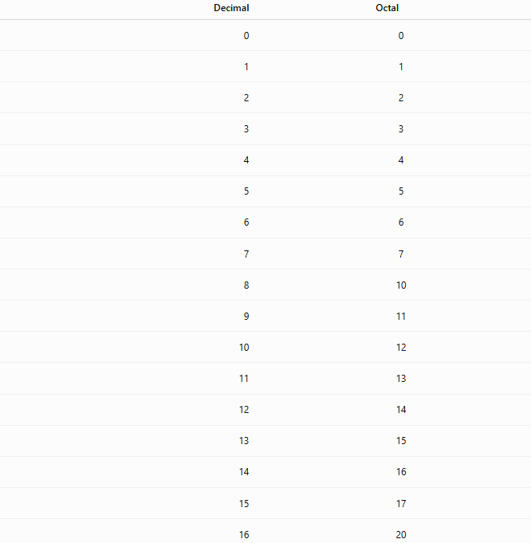
Decimal | Octal
0 | 0
1 | 1
2 | 2
3 | 3
4 | 4
5 | 5
6 | 6
7 | 7
8 | 10
9 | 11
10 | 12
11 | 13
12 | 14
13 | 15
14 | 16
15 | 17
16 | 20

Octal Place Value Chart
# Source: AI Source: Provided by: [Data Path: Persons Table -> ID Column: 1, Name_En Column: Motasem Essam] -> From: [ChatGPT] on [7/16/2026]
$$8^{5}$$ | $$8^{4}$$ | $$8^{3}$$ | $$8^{2}$$ | $$8^{1}$$ | $$8^{0}$$
32768 | 4096 | 512 | 64 | 8 | 1
Example:
$${6352}_{8} \\ =6(512)+3(64)+5(8)+2 \\ =3072+192+40+2={3306}_{10}$$

Octal Fractions
# Source: AI Source: Provided by: [Data Path: Persons Table -> ID Column: 1, Name_En Column: Motasem Essam] -> From: [ChatGPT] on [7/16/2026]
Digits to the right of the octal point represent negative powers of 8.
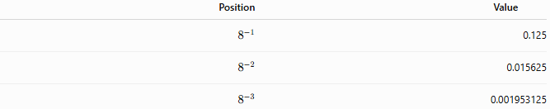
Position | Value
$$8^{-1}$$ | 0.125
$$8^{-2}$$ | 0.015625
$$8^{-3}$$ | 0.001953125
Example:
$${12.4}_{8} \\ =1×8+2+4×\frac{1}{8} \\ =8+2+0.5={10.5}_{10}$$

Relationship with Binary
# Source: AI Source: Provided by: [Data Path: Persons Table -> ID Column: 1, Name_En Column: Motasem Essam] -> From: [ChatGPT] on [7/16/2026]
One octal digit corresponds exactly to three binary digits.
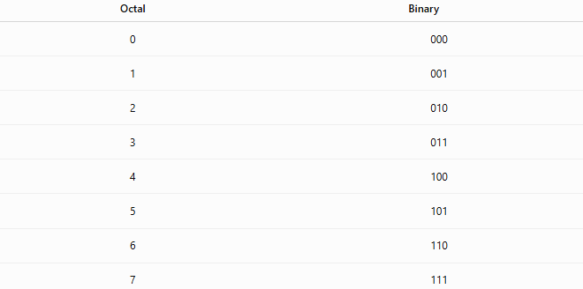
Octal | Binary
0 | 000
1 | 001
2 | 010
3 | 011
4 | 100
5 | 101
6 | 110
7 | 111
Example:
$${725}_{8}$$
becomes
$$111 010 {101}_{2}$$

Characteristics
# Source: AI Source: Provided by: [Data Path: Persons Table -> ID Column: 1, Name_En Column: Motasem Essam] -> From: [ChatGPT] on [7/16/2026]
The octal numeral system:
- Is a positional numeral system.
- Uses Base 8.
- Uses eight digits (0–7).
- Uses powers of 8 for place values.
- Has a simple relationship with binary.

Arithmetic Operations
# Source: AI Source: Provided by: [Data Path: Persons Table -> ID Column: 1, Name_En Column: Motasem Essam] -> From: [ChatGPT] on [7/16/2026]
Standard arithmetic operations apply in base 8.
Addition
$$7_{8}+1_{8}={10}_{8}$$

Subtraction
$${20}_{8}-5_{8}={13}_{8}$$

Multiplication
$$7_{8}×2_{8}={16}_{8}$$
because
$$7×2={14}_{10}={16}_{8}.$$

Division
$${20}_{8}÷2_{8}={10}_{8}$$

Applications
# Source: AI Source: Provided by: [Data Path: Persons Table -> ID Column: 1, Name_En Column: Motasem Essam] -> From: [ChatGPT] on [7/16/2026]
The octal system is used in:
- Computer Science
- Operating Systems
- UNIX/Linux permissions
- Embedded Systems
- Digital Electronics
- Computer Architecture
- Legacy Computing
- Programming Languages
- File Systems
- Digital Design

Real-Life Applications
# Source: AI Source: Provided by: [Data Path: Persons Table -> ID Column: 1, Name_En Column: Motasem Essam] -> From: [ChatGPT] on [7/16/2026]
Octal notation is commonly found in:
- UNIX/Linux file permissions (e.g., 755, 644)
- Some assembly languages
- Embedded software
- Historical computer systems
- Digital hardware documentation

Advantages
# Source: AI Source: Provided by: [Data Path: Persons Table -> ID Column: 1, Name_En Column: Motasem Essam] -> From: [ChatGPT] on [7/16/2026]
The octal system:
- Is more compact than binary.
- Converts easily to and from binary.
- Is simpler to read than long binary strings.
- Was efficient for early computer architectures.

Disadvantages
# Source: AI Source: Provided by: [Data Path: Persons Table -> ID Column: 1, Name_En Column: Motasem Essam] -> From: [ChatGPT] on [7/16/2026]
The octal system:
- Is less familiar than decimal.
- Has largely been replaced by hexadecimal in modern computing.
- Represents binary less compactly than hexadecimal.

Common Mistakes
# Source: AI Source: Provided by: [Data Path: Persons Table -> ID Column: 1, Name_En Column: Motasem Essam] -> From: [ChatGPT] on [7/16/2026]
- Using digits 8 or 9 in octal numbers.
- Forgetting that each position represents a power of 8.
- Reading octal numbers as decimal numbers.
- Confusing octal with hexadecimal.

Key Points
# Source: AI Source: Provided by: [Data Path: Persons Table -> ID Column: 1, Name_En Column: Motasem Essam] -> From: [ChatGPT] on [7/16/2026]
- Octal is a Base 8 positional numeral system.
- It uses the digits 0–7 only.
- Each position represents a power of 8.
- One octal digit corresponds to three binary bits.
- Octal is still used in UNIX/Linux permissions and some computing applications.

Octal vs. Binary
# Source: AI Source: Provided by: [Data Path: Persons Table -> ID Column: 1, Name_En Column: Motasem Essam] -> From: [ChatGPT] on [7/16/2026]
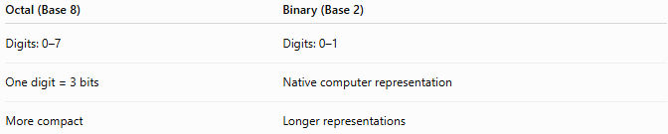
Octal (Base 8) | Binary (Base 2)
Digits: 0–7 | Digits: 0–1
One digit = 3 bits | Native computer representation
More compact | Longer representations

Octal vs. Decimal
# Source: AI Source: Provided by: [Data Path: Persons Table -> ID Column: 1, Name_En Column: Motasem Essam] -> From: [ChatGPT] on [7/16/2026]
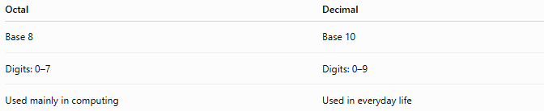
Octal | Decimal
Base 8 | Base 10
Digits: 0–7 | Digits: 0–9
Used mainly in computing | Used in everyday life

Octal vs. Hexadecimal
# Source: AI Source: Provided by: [Data Path: Persons Table -> ID Column: 1, Name_En Column: Motasem Essam] -> From: [ChatGPT] on [7/16/2026]
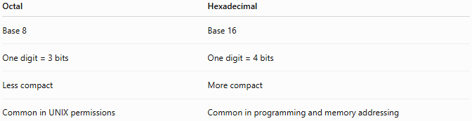
Octal | Hexadecimal
Base 8 | Base 16
One digit = 3 bits | One digit = 4 bits
Less compact | More compact
Common in UNIX permissions | Common in programming and memory addressing

Conclusion
# Source: AI Source: Provided by: [Data Path: Persons Table -> ID Column: 1, Name_En Column: Motasem Essam] -> From: [ChatGPT] on [7/16/2026]
The Octal Numeral System is a Base 8 positional numeral system that uses the digits 0 through 7, with each position representing a power of 8. It provides a compact representation of binary numbers because each octal digit corresponds exactly to three binary bits. Although largely replaced by hexadecimal in modern computing, octal remains important in operating systems, embedded computing, and historical computer architecture, making it an essential numeral system to understand in mathematics and computer science.

